Mi Gao

migao@bu.edu

Assignment 2.0 Performance Tuning

MET CS 779

MET CS 779 Assignment 2.0

Table of Contents

1. Part A 3

1) Document what DDL changes you need to make and provide the SQL and the screenshots showing the changes being made. 3

2) Document the record count from the loaded tables by providing the screenshot. 3

2. Part B Question 1 3

3) What changes would you make to the provided schema so that it can scale to handle a million or more transactions per day? Identify the scalability-limiting schema features and propose changes that would make them scalable. 4

4) Would you denormalize? If you would denormalize, how would you maintain the denormalizations? Justify your design changes regardless of your decision about whether to denormalize. 4

5) Please provide parts of the ERD design changes you are proposing with your suggested changes and paste it below. 4

3. Part B Question 2 4

6) How would you design a denormalized RentalHistory table to reduce the number of tables that need to be joined? 4

7) How would you maintain this data, meaning how and when would it be populated and updated? Compare and contrast some different approaches (think stored procedures vs. triggers). 4

8) **Provide an ERD design** for the RentalHistory table with your suggestions and the explanations of your changes including an ERD of the RentalHistory table below. 5

4. Part C 5

1) Below query is used to identify DVDs that are similar to the DVDs that the member has rented, in this case based on the director of the movie. 5

2) Queries like the following are run frequently to identify DVDs that a member has not rented. Note that the MemberID is passed from the application layer and may be different each time the query is run. 5

3) The following view assembles the data for a DVD in a form useful for output to a user interface, so it is used extensively by the application. 5

4) Review your solution to question 7 from Programming Assignment Part 1. Customer is reporting that it is running slow. Recall the question asked to list all the Members and the DVD Copies they have currently rented and not returned using a subquery. A currently Rented DVD is where the RentalReturnedDate is NULL. The attributes returned were Member’s name, DVDTitle, Genre, Rating, a director if one exists in the database, DVD Copy, and the request and ship dates for each DVD. The Customer just cares about which movies have been rented and not returned at minimum. 6

5) Review your solution to question 9 from Programming Assignment Part 1. Customer is reporting that it is running slow. Recall that the question asked for a query to list the DVD titles and how many times each one has been rented. The result should be DVD Title, Genre, Rating and number of rentals for each DVD. 6

6) There are many ways to improve the scalable performance of the following stored procedure, which is running increasingly slowly as the database grows. Identify the changes to improve the scalable performance of this stored procedure. 6

5. Conclusion 7

5. Revision History 8

# Part A

## Document what DDL changes you need to make and provide the SQL and the screenshots showing the changes being made.

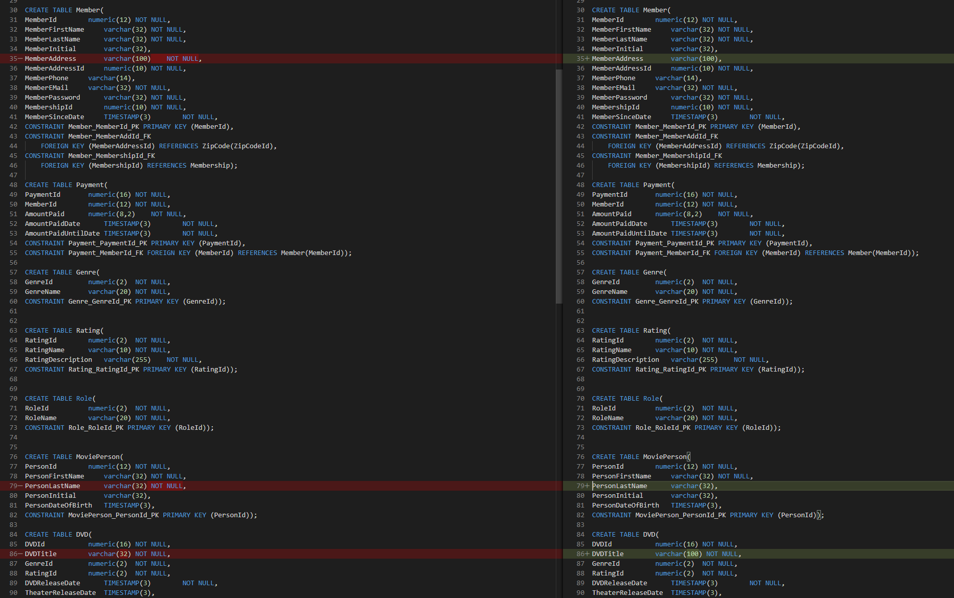

Member table:

MemberAddress varchar(100) NOT NULL 🡪 MemberAddress varchar(100)

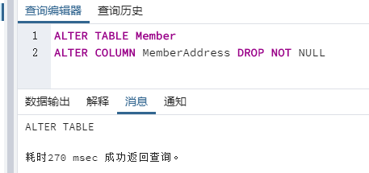



MoviePerson table:

PersonLastName varchar(32) NOT NULL 🡪 PersonLastName varchar(32)

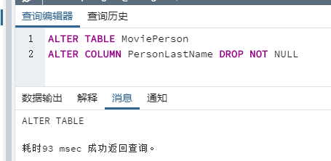



DVD table:

DVDTitle varchar(32) NOT NULL 🡪 DVDTitle varchar(100) NOT NULL

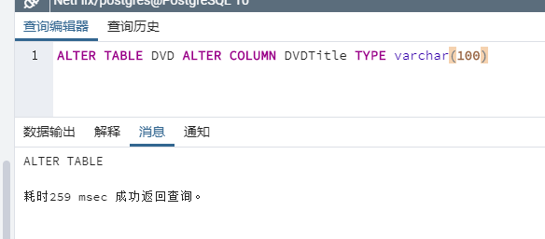 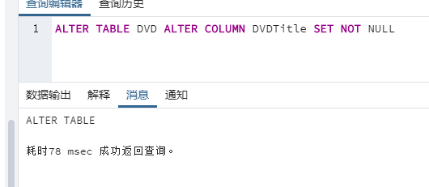



And for indexs, there has a new unique index been created in the original one:

CREATE UNIQUE INDEX I_DVDTitle ON DVD(DVDTitle);

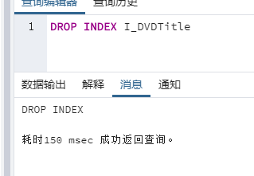

Also I need to drop extra column I made in last assignment for run script in rental table successfully.

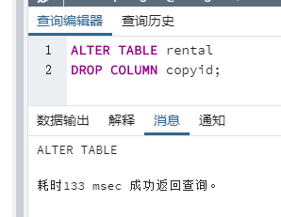

## Document the record count from the loaded tables by providing the screenshot.

I did not see the way like Oracle and SQL SERVER to execute sql files in once so I just do separately. And I use the query and function to count how many tuples I have after I inserted.

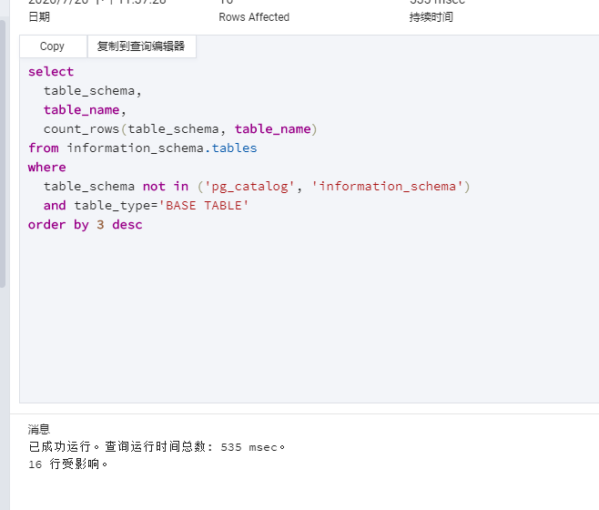

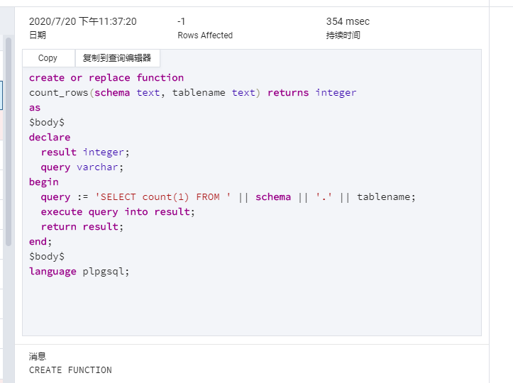

Before I insert new data from scripts:

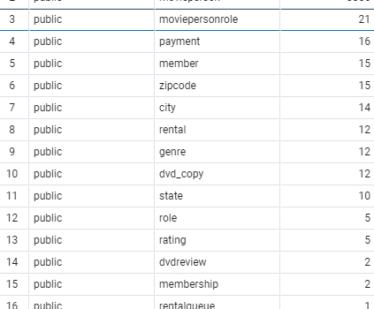

After inserted:

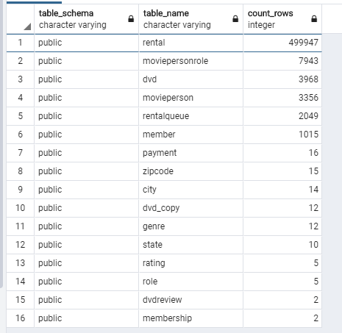

# Part B Question 1

## What changes would you make to the provided schema so that it can scale to handle a million or more transactions per day? Identify the scalability-limiting schema features and propose changes that would make them scalable.

If we talk about scalability, the first thing I thought will be denormalization. If I may add some indexes to handle such lots of transactions each day. Also, denormalizing some tables to avoid joining multiple tables to retrieve data will be good. After indexing attributes, data between millions of records will be retrieved faster. In my opinion, I need to access several tables in the original schema to retrieve data, so indexing required attributes and denormalizing some tables into large tables is essential to improve scalability.

Although performance is reduced when adding or updating data, indexes can speed up searches and queries. So I want to index the following fields: frequently searched fields, sorted fields, and fields in other tables that are joined to multiple table queries; in which means, those foreign keys are the main target to set the index. Therefore, the keys in tables such as dvd, dvd_copy, member and payment without rentalqueue will be nice because users may usually modified their wish list. So that, I think when query for the payment, the rental records, and monthly billing of each customer’s credit card can be faster at least.

## Would you denormalize? If you would denormalize, how would you maintain the denormalizations? Justify your design changes regardless of your decision about whether to denormalize.

In my opinion, I will denormalize for sure if I want to improve my performance. So far, if I want to query the rental history, the best and fastest way might be put them all together. So that I think I need to put at least dvdid, memberid, member’s name and dvd’s copyid to get there to help user to quickly query the rental. Last time, I combined copyid into rental table as foreign key; however, I dropped that column for insert/load new data successfully. Anyway, when we need query rental information about a member, in this case, we can easily retrieve the information by joining a few tables.

## Please provide parts of the ERD design changes you are proposing with your suggested changes and paste it below.

Notice: I imported CSV from my PostgreSQL schema on Lucidchart and kept working on it so that why this show like this format.

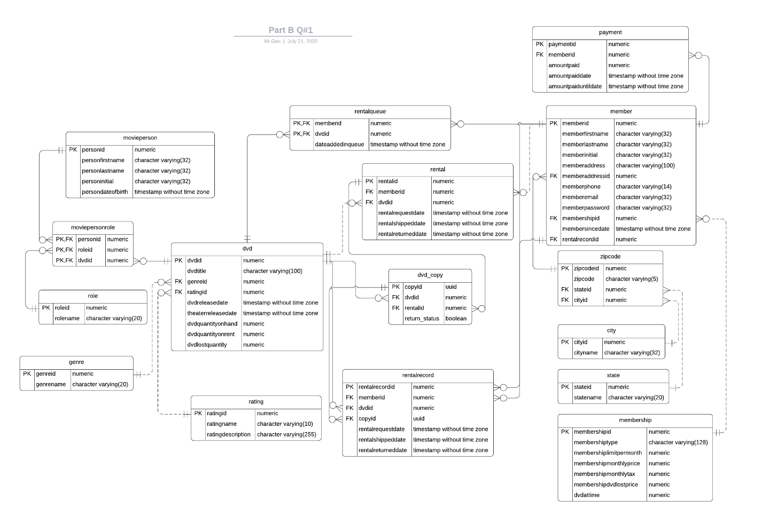

# Part B Question 2

## How would you design a denormalized RentalHistory table to reduce the number of tables that need to be joined?

I find this question I just did in above for improve the speed of querying rental record so that I will do this based on it in this question. I may just add few more things on it if we need such as the director and genre. Therefore, I will not repeat same paragraphs for saving your reading time. I will introduce what we have in this table.

|  |  |
| --- | --- |
| rentalhisoryid | Primary key for the table |
| memberid | Foreign key to member table for member infomation |
| dvdid | Foreign key to dvd table for dvd name |
| personid | Foreign key to movieperson table for the director |
| genreid | Foreign key to genre for genre name |
| copyid | Foreign key to dvd_copy for the UUID |
| rentalrequestdate | Request date |
| rentalshippeddate | Shipped date |
| rentalreturneddate | Returned date |

According to this table, we can get all things we need faster then go through the relationships made by normalization when review our rental history.

## How would you maintain this data, meaning how and when would it be populated and updated? Compare and contrast some different approaches (think stored procedures vs. triggers).

When a business processes multiple tables at the same time, it is more appropriate to use a stored procedure. The use of stored procedures will improve performance in general, because the database optimizes the data access plan of the stored procedures and applies the cache to facilitate future checks. Any request for the DVD can create tuple to record.

Also, I would like to use trigger to update the values in the table. For example, when insert or update a value in rental such as the return date, the values in rental history will been created or updated; then, we will know anything about this record. Or

## **Provide an ERD design** for the RentalHistory table with your suggestions and the explanations of your changes including an ERD of the RentalHistory table below.

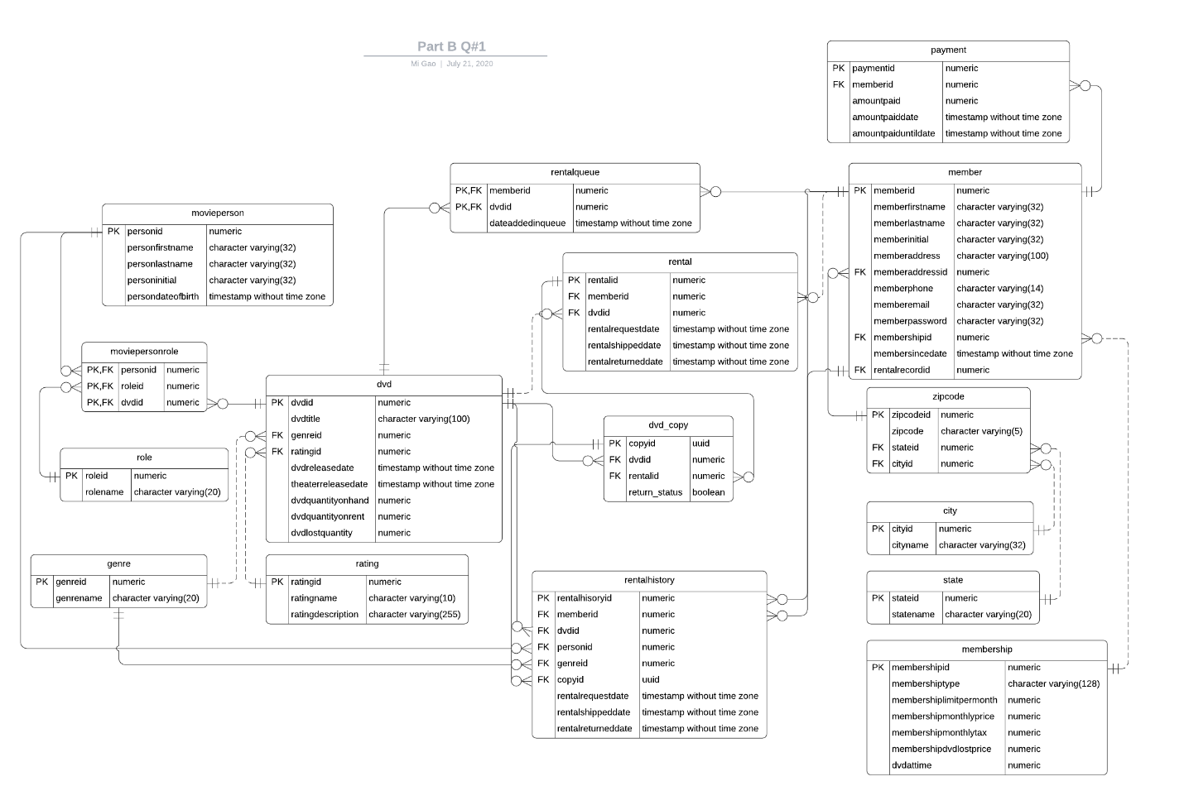

# Part C

## Below query is used to identify DVDs that are similar to the DVDs that the member has rented, in this case based on the director of the movie.

* 1. What performance issues do you see with this query? Examine the execution plan to confirm your concerns. Are you seeing something within the execution plan which you did not consider?
  2. Your recommendation to improve performance:

## Queries like the following are run frequently to identify DVDs that a member has not rented. Note that the MemberID is passed from the application layer and may be different each time the query is run.

* 1. What performance issues do you see with this query? Examine the execution plan to confirm your concerns. Are you seeing something within the execution plan which you did not consider?
  2. Your recommendation to improve performance:

## The following view assembles the data for a DVD in a form useful for output to a user interface, so it is used extensively by the application.

* 1. What performance issues do you see with this query? Examine the execution plan to confirm your concerns. Are you seeing something within the execution plan which you did not consider?
  2. Your recommendation to improve performance:

## Review your solution to question 7 from Programming Assignment Part 1. Customer is reporting that it is running slow. Recall the question asked to list all the Members and the DVD Copies they have currently rented and not returned using a subquery. A currently Rented DVD is where the RentalReturnedDate is NULL. The attributes returned were Member’s name, DVDTitle, Genre, Rating, a director if one exists in the database, DVD Copy, and the request and ship dates for each DVD. The Customer just cares about which movies have been rented and not returned at minimum.

* 1. What performance issues do you see with this query? Examine the execution plan to confirm your concerns. Are you seeing something within the execution plan which you did not consider?
  2. Your recommendation to improve performance:

## Review your solution to question 9 from Programming Assignment Part 1. Customer is reporting that it is running slow. Recall that the question asked for a query to list the DVD titles and how many times each one has been rented. The result should be DVD Title, Genre, Rating and number of rentals for each DVD.

* 1. What performance issues do you see with this query? Examine the execution plan to confirm your concerns. Are you seeing something within the execution plan which you did not consider?
  2. Your recommendation to improve performance:

## There are many ways to improve the scalable performance of the following stored procedure, which is running increasingly slowly as the database grows. Identify the changes to improve the scalable performance of this stored procedure.

* 1. What performance issues do you see with this stored procedure:
  2. Your recommendation to improve performance:

# Conclusion

Provide a summary of the document. Include any hang-ups you might have encountered or what you learned. This section may not always be applicable.

# 5. Revision History

|  |  |  |  |
| --- | --- | --- | --- |
| **Name** | **Date** | **Version** | **Description** |
| Mi Gao | 07/19/20 | 1.0 | Initial Document Creation |
| Mi Gao | 07/21/20 | 1.5 | Added more contents |